**MUSIC PLAYER**

Table of Contents

1. About the Project

1.1 Description

1.2 Features

1. Requirements

2.1 High level requirements

2.2 Low level requirements

1. Block diagram

3.1 Sensor

3.2 Actuator

3.3 Microcontroller

1. Test plan
2. Application

**ABOUT THE PROJECT**

Description

The music player is an embedded system. This project is about the music player application development using Arduino UNO. The biggest difference between the music player and existing applications is that it is completely free for users to use. It will integrate the advantages of existing music players on the market, as far as possible to mining out the existing music players' function, and then do the filtering in order to eliminate function that not practical or low cost-effective. Also, it will be keep improved based on user feedback.

Features

- Push buttons for user inputs (play/pause, previous, next)

- Speaker as output device

- LCD to display which song is played

**REQUIREMENTS**

Some of the requirements noted for this project are:

High Level Requirements-

|  |  |
| --- | --- |
| ID | HLRs |
| HLR1 | Play music |
| HLR2 | Play/ pause the songs |
| HLR3 | Play previous and/or next song |

Low Level Requirements-

|  |  |
| --- | --- |
| LLR ID | HLR1 |
| LLR1 | Better sound quality |
| LLR2 | Less noise |

|  |  |
| --- | --- |
| LLR ID | HLR2 |
| LLR1 | Take less time to process user input |
| LLR2 | Delay should be max 1us |

|  |  |
| --- | --- |
| LLR ID | HLR3 |
| LLR1 | Take less time to process user input |
| LLR2 | Delay should be max 1us |

**BLOCK DIAGRAM**

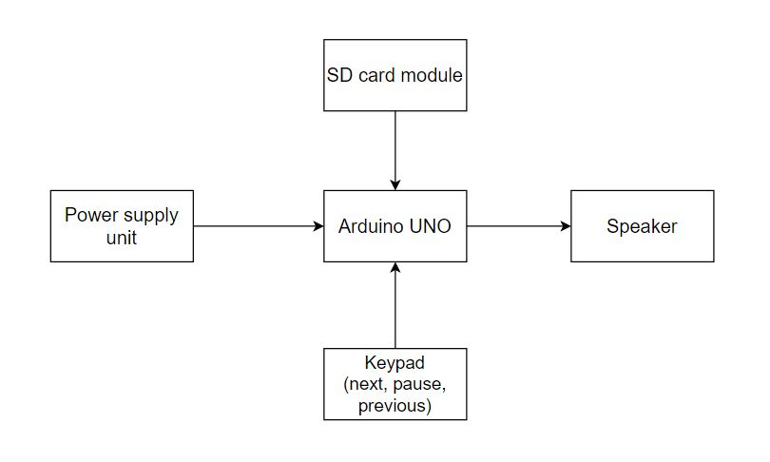

The block diagram of the music player is shown above. It briefly says how the music player actually works.

Sensors

* Keypad (push button keys)
* SD card reader

Actuators

* LCD display

Microcontroller

* Arduino UNO – It is an Arduino board.

**TEST PLAN**

|  |  |  |
| --- | --- | --- |
| Input mode | Expected Output | Actual Output |
| Keypad | Play/ pause | Play/pause |
| Keypad | Next song | Next song |

**APPLICATION**

* It can be coded in song playing apps.
* It can be further manufactured to devices that play only music.